=================================== 2nd_Mini Projects doubts ==========================

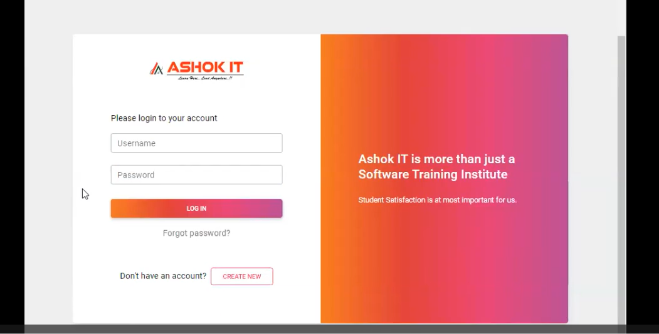

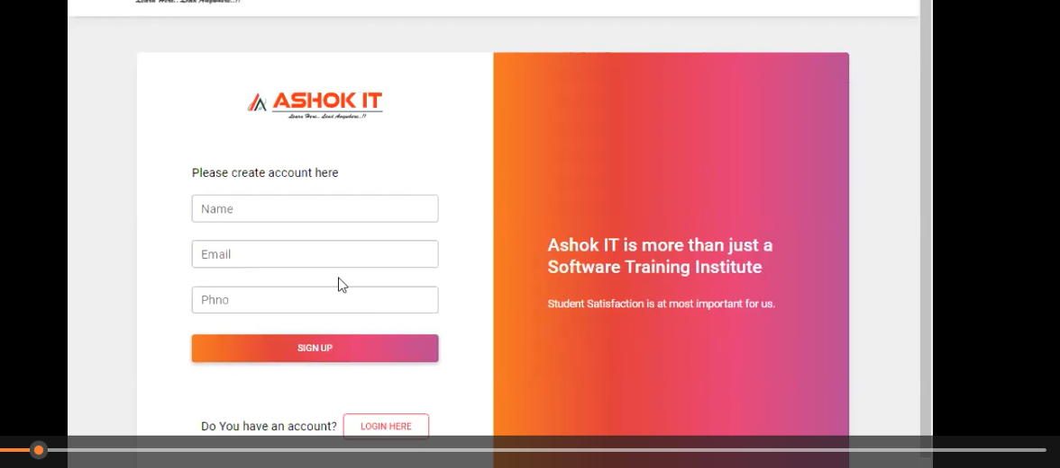

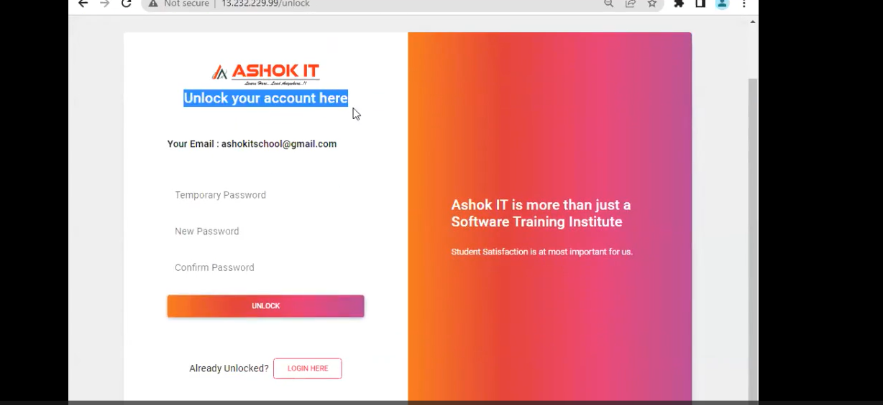

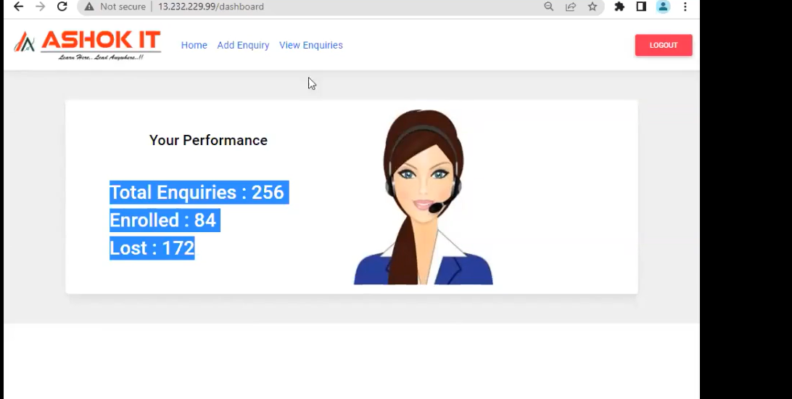

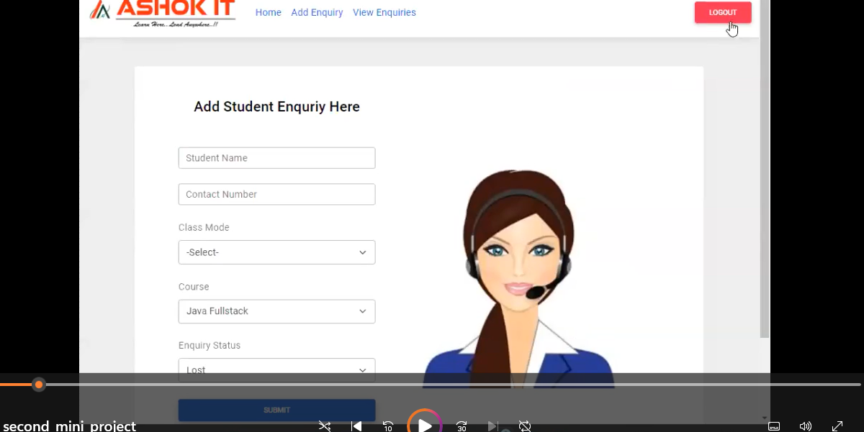

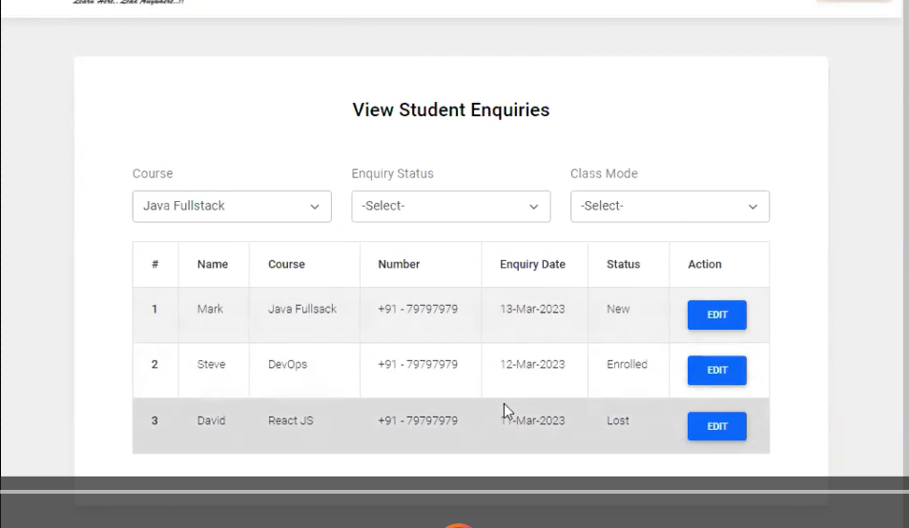

Option 1: HttpSession (built-in Spring session) – SIMPLE
Option 2: Custom Session Store (our own Map)
Clear differences between both
I’ll start with HttpSession, because it’s easier for you right now.

✅ OPTION 1 — Using HttpSession (recommended for you now)

🔹 IDEA
After successful login, we will:
store userId in the session → session.setAttribute("userId", user.getUserId());
In other APIs (like /performance), we will:
read userId from session → session.getAttribute("userId");
Spring handles session ID + cookie (JSESSIONID) automatically.

🧩 STEP 1: Change your Login Controller
Right now you have:
@GetMapping("/login")
public ResponseEntity<?> login(@RequestBody LoginForm loginForm) {
Login_ResponcesForm Data = userService.loginCheck(loginForm);
if ("FAILED".equals(Data.getSataus())) {
return ResponseEntity.badRequest().body(Data);
} else {
return ResponseEntity.ok(Data);
}
}
👉 Update it to:
@PostMapping("/login") // better to use POST for login
public ResponseEntity<?> login(@RequestBody LoginForm loginForm,
HttpSession session) {

Login_ResponcesForm data = userService.loginCheck(loginForm, session);

if ("FAILED".equals(data.getSataus())) {
return ResponseEntity.badRequest().body(data);
} else {
return ResponseEntity.ok(data);
}
}
🔸 Changes made:
@GetMapping ➝ @PostMapping (recommended for login)
Added HttpSession session in method params
Calling new service method: loginCheck(loginForm, session)

🧩 STEP 2: Change your loginCheck method in UserService
Your current code:
public Login_ResponcesForm loginCheck(LoginForm loginForm) {
UserDtlsEntity byEmailAndUserPsw = userDtlsRepo.findByUserEmailAndUserPassword(
loginForm.getUserEmail(), loginForm.getUserPsw());

Login_ResponcesForm loginResponcesForm = new Login_ResponcesForm();
// ... rest logic
}
👉 Change it to this:
public Login_ResponcesForm loginCheck(LoginForm loginForm, HttpSession session) {

UserDtlsEntity user = userDtlsRepo.findByUserEmailAndUserPassword(
loginForm.getUserEmail(),
loginForm.getUserPsw()
);

Login_ResponcesForm res = new Login_ResponcesForm();

if (user == null) {
res.setSataus("FAILED");
res.setMassage("Invalid Credentials");
return res;
} else if ("LOCKED".equals(user.getUserAccStatus())) {
res.setUserName(user.getUserName());
res.setSataus("FAILED");
res.setMassage("Your Account is Locked. Please unlock your account.");
return res;
} else {
// ✅ SUCCESS LOGIN

// 🔴 IMPORTANT: store logged-in user in session
session.setAttribute("userId", user.getUserId());
session.setAttribute("userName", user.getUserName()); // optional

res.setUserName(user.getUserName());
res.setSataus("SUCCESS");
res.setMassage("Login Successful");

return res;
}
}
📌 Now after successful login:
Spring creates a session.
It sets a cookie JSESSIONID to client.
Your userId is stored in that session.

🧩 STEP 3: Use that session in another API (e.g. Performance API)
Now you said:
based on login user i want build one more rest api for user performances
Let’s say your new API is:
@GetMapping("/performance")
public ResponseEntity<?> getUserPerformance(HttpSession session) {

// 👇 get userId from session
Long userId = (Long) session.getAttribute("userId");

if (userId == null) {
// no login / session expired
return ResponseEntity.status(401).body("Not logged in or session expired");
}

// now you have logged-in userId, call service
UserPerformanceDto performance = userService.getUserPerformance(userId);

return ResponseEntity.ok(performance);
}
What you have to do here:
Add HttpSession session parameter.
Read userId from session.
If null → user is not logged in or session expired.
If not null → proceed with business logic.

🧪 STEP 4: How to test this in Postman or Browser?
First call: POST /login
Body (JSON):
{
"userEmail": "test@gmail.com",
"userPsw": "1234"
}
If credentials correct:
You get response Login Successful
Response will also include Set-Cookie: JSESSIONID=...
Second call: GET /performance
Same Postman tab / same cookie storage
Postman will automatically send back that JSESSIONID
Spring reads session → gets userId → your API works
⚠️ Make sure in Postman:
"Enable cookie" / "Manage Cookies" has JSESSIONID stored.
Don’t change environment or domain between requests.

✅ OPTION 2 — Custom Session Store (our own SessionService + Map)
This is the one I suggested earlier.

🔹 IDEA
We create our own sessionId (a random string).
We store mapping: sessionId -> userId in a Map.
We return sessionId in login response.
Client must send sessionId in header or request param for next APIs.

🔹 What code looks like (summary)
1. Create SessionService
@Service
public class SessionService {

private Map<String, Long> sessions = new ConcurrentHashMap<>();

public String createSession(Long userId) {
String sessionId = UUID.randomUUID().toString();
sessions.put(sessionId, userId);
return sessionId;
}

public Long getUserId(String sessionId) {
return sessions.get(sessionId);
}

public void removeSession(String sessionId) {
sessions.remove(sessionId);
}
}
2. On login success:
String sessionId = sessionService.createSession(user.getUserId());
res.setSessionId(sessionId);
3. For performance API:
@GetMapping("/performance")
public ResponseEntity<?> getPerformance(@RequestHeader("sessionId") String sessionId) {
Long userId = sessionService.getUserId(sessionId);
...
}
So here:
We manage everything manually.
No HttpSession, no cookies.
More like a simple token-based authentication.

🔍 Difference Between HttpSession vs Custom Session Store
Feature | HttpSession (built-in) | Custom Session Store (Map + sessionId)
Who manages session | Spring / Servlet container | You (your code)
Session ID name | JSESSIONID cookie | Whatever you create (e.g., "sessionId")
How sessionId is sent | Via cookie automatically | Via header or request param manually
Storage | In server memory (by container) | In Map in your app (also memory)
Code complexity | ✅ Simple, less code | 🔸 More manual handling
Good for | Web apps, simple backend | Learning custom logic, custom token-based flows
Logout / invalidate | session.invalidate() | sessionService.removeSession(sessionId)

🔚 What should YOU use now?
For your current level and mini project:
👉 Use HttpSession (OPTION 1).
You only need to:
Modify login controller → add HttpSession
Modify loginCheck service method → store userId in session
In next APIs → read userId from HttpSession
If you send me:
your full Controller class
your UserService class
I can rewrite them fully for you with session handling included, line by line.

